
Lesson 5: Enemy Ranks
001 Game Creator (Windows only)
VIDEO GAME CREATION
This week: one enemy becomes many. Your job is to turn last week's single enemy into a whole row of them, using a loop instead of repeating yourself by hand.
Open your own [YourName]Game project from Lesson 4 - don't start a new one. Everything this week builds on the enemy and collision detection you already have.
Tip: no new assets this week - you're reusing bullet_yellow.png, sfx_shoot.wav, enemy_invader_red.png, and sfx_hit.wav from your Lesson 3 and 4 Assets folders.

Setup
- Open your [YourName]Game project from Lesson 4.
- Select your existing enemy Actor on the Map, copy it (Ctrl+C), then paste (Ctrl+V) 4 more times, spacing each copy out in a row with at least a full enemy-width of empty gap between each one so they don't touch - unlike the other engines this week, 001 Game Creator doesn't need a loop at all for this part.

Level 1 - Minimal (MVP)
Several enemies sit on screen in a row, created by a loop instead of placed or spawned one at a time. Shooting any one of them destroys just that one. This is a complete finish for today - reaching this is enough to move on to next week.
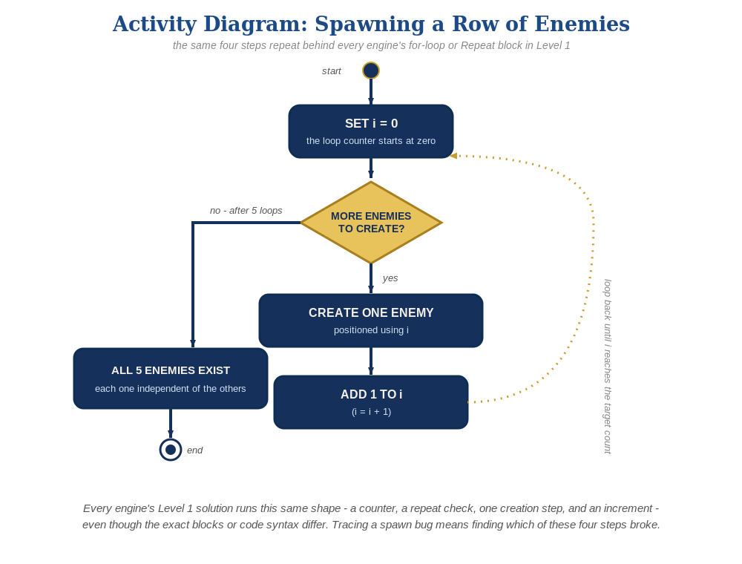
The spawn loop, in general - the same counter, repeat check, creation step, and increment behind Level 1 in every engine, whatever the exact blocks or syntax look like.
- Save, then Play/Test and shoot different enemies in the row - each one should disappear independently when hit, with zero new scripting.
No new script needed - every pasted copy of the enemy Actor automatically keeps its own "Collided with actor" Trigger script, since Trigger scripts belong to the Actor Template, not to any one placed copy.

Level 2 - Complete (Alpha/Beta)
Every enemy in the row can be individually shot and destroyed without affecting the others, and a bullet that misses every enemy still behaves exactly like it did last week.
- Shoot several different enemies in a row, including some misses - each hit destroys exactly the one enemy Actor that was actually touched, and every other enemy is unaffected.
- This already works with no extra scripting: every placed copy of an Actor Template runs its own independent copy of that Template's Triggers, the same way every copy of an object/prefab/scene behaves independently in every other engine this course uses.

Level 3 - Refined (Ready to Publish) - pick any that interest you
- Sound: this already works with no changes - the "Play Sound" event in the enemy's "Collided with actor" script runs independently for every copy that gets hit.
- Visual: give a couple of the pasted copies a slightly different Tint (Actor > Graphics Options > Tint, set per-instance rather than on the Template - a hex color picker) for a bit of row-to-row variety. Try #C81937 (a deep crimson red) on some copies and #E66482 (a lighter dusty rose/pink) on others, so the row shows visibly different shades of red rather than a blended new color.
- Structure: no change needed - the same "everything about being hit lives on the enemy Actor's own Trigger" structure from Lesson 4 already scales to any number of copies for free.

If Something's Wrong
- Only one enemy reacts to being shot: confirm each pasted copy is actually a separate placed Actor (Ctrl+V creates independent copies) and not, for example, the same Actor accidentally dragged back and forth.
- Enemies overlap each other: spread the pasted copies out further apart on the Map before saving.
- A copy doesn't react at all: confirm "Initially Existent" is still ticked on that copy - copy/paste sometimes needs this double-checked per copy depending on version.

Want More?
001gamecreator.com/wiki, Student Resource List > 001 Game Creator

